Retail Revenue Leakage Analysis
- Project Overview
A leading retail chain with operations across multiple regions has experienced sustained revenue growth over the past three years. Despite this positive sales performance, the company has observed a consistent decline in overall profitability, raising concerns about operational efficiency and financial performance. This discrepancy between increasing revenue and declining profit suggests that revenue leakage may be occurring within various aspects of the business.
To investigate this challenge, a comprehensive business analysis was conducted to identify the underlying factors contributing to the company's declining profitability and uncover areas where revenue leakage was occurring. The objective of the project is to uncover areas where revenue is being lost by analyzing sales performance, profit margins, discounts, shipping costs, product performance, customer profitability, and regional operations.
Using Excel, Python, SQL and Microsoft Power BI, the project employs a data-driven approach to transform, model, and analyze retail sales data. Through interactive dashboards and key performance indicators (KPIs), the analysis provides actionable insights to support management in identifying operational inefficiencies, reducing revenue leakage, and implementing strategies to improve overall profitability while sustaining revenue growth.
- Dataset Summary
2.1 Fact Sales Table : is the central transactional table in the retail data model and contains detailed records of every sales transaction processed by the company. This table serves as the primary source for analyzing revenue generation, operational efficiency, and profitability across different business dimensions.
Table 1 : Fact_sales key features
Category | Variables | Description
Shipping Information | Ship_mode, days_to_ship | Describes the shipping method used and the number of days required to deliver each order.
Sales Metrics | quantity, unit_price, discount_pct, sales | Measures product quantities sold, pricing, discounts applied, and total sales revenue generated.
Cost Metrics | cogs, shipping_cost | Represents the cost of goods sold and shipping expenses incurred for each transaction.
Profitability Metric | gross_profit, operating_profit, profit_margin_pct, margin_class | Measures financial performance by calculating gross profit, operating profit, profit margin percentage, and categorizing transactions based on profitability levels.

  - Product Table : contains descriptive information about the products sold by the retail business Each record in the table represents a unique product and is identified by a unique Product ID, which is used to establish a one-to-many relationship with the Fact_Sales table.

Rows:
Columns :

Table 2 : key feature of Product Table
Variable | Description
Product name | The descriptive name of the product sold.
category | The primary classification of the product (e.g., Furniture, Office Supplies, Technology).
sub_category | A more detailed classification within each product category (e.g., Chairs, Phones, Storage).

  - . Customer Table
This table contains descriptive information about the company's customers. Each record in the table represents a unique customer and is identified by a unique Customer ID that was used to establish relationship with the Fact Sales table. This relationship enables sales transactions to be analyzed at the individual customer and customer segment levels.
Rows :
Columns :
Table 3. Customer Table key features
Variable | Description
Customer name | The full name or identifier of the customer.
Segment | The customer segment to which the customer belongs (e.g., Consumer, Corporate, Home Office), enabling customer classification and segmentation analysis.

  - Stores Table
contains descriptive information about the company's retail branches and their geographical locations. Each record in the table represents a unique retail branch and is linked to the Fact_Sales table through the Location ID.
Table 4. Customer Table key features
Variable | Description
branch name | The name of the retail branch where the transaction occurred.
region | The geographical region in which the branch operates, enabling regional sales and profitability analysis.

- Exploratory Data Analysis with Python
Exploratory Data Analysis was performed to identify trends, patterns, and potential sources of revenue leakage.
The analysis focused on several key business areas.
  - Revenue Analysis
Revenue trends were examined to understand overall sales performance and identify patterns across the dataset.
  - Profitability Analysis
Profitability metrics were analyzed to evaluate the relationship between revenue generation and operating profit.
  - Product Performance Analysis
Product categories and individual products were evaluated to identify:
- High-performing products
- Low-performing products
- Products generating consistently low profits
Special attention was given to the Top 7 products with the lowest profitability.

  - Store Performance Analysis
Operating profit was analyzed across different retail branches to identify stores requiring operational attention.
  - Customer Segment Analysis
Customer profitability was examined across different customer segments to determine which segments contributed most to revenue and profit.
  - Shipping Analysis
Shipping modes were analyzed to assess their impact on operational profitability.
  - Discount Analysis
The relationship between discounts and profitability was investigated to determine whether discounting strategies contributed to revenue leakage.
Scatter plot analysis revealed a negative relationship between discount percentage and operating profit, indicating that profitability declined as discounts increased. Transactions with discounts above approximately 15% showed a higher likelihood of generating losses.

Preparation for SQL and Power BI
Following the completion of exploratory analysis, the cleaned and normalized datasets were exported for further analysis in SQL Server Management Studio (SSMS) and Power BI.
SQL was used to perform business-focused analytical queries, while Power BI was used to build a star schema, develop DAX measures, and create interactive dashboards for executive decision-making.

Data Analysis Using SQL
Table 5. Report showing the key metrics
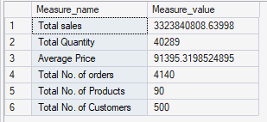

Question2: Which product categories underperformed?
Question: Which product categories underperformed?
The Electronics, and Sport & Leisure underperformed across all regions
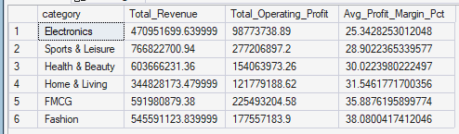
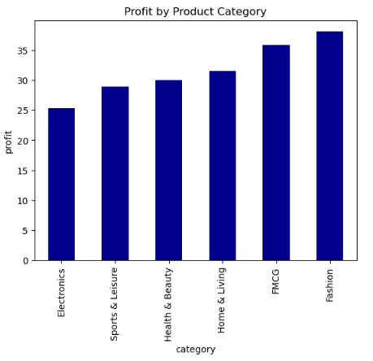
Question : Are discounts reducing profitability?
Discount Band of 11% -20% upward generated low profit.
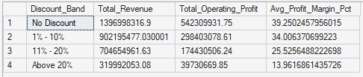
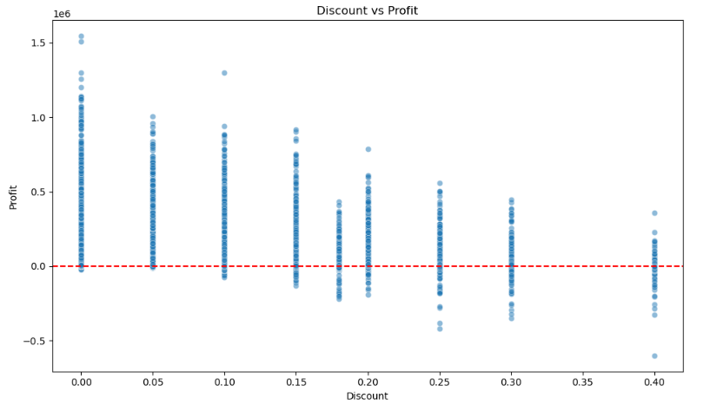

Question : Is the shipping method affecting the revenue?
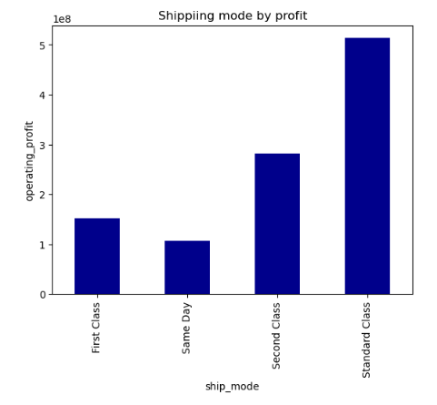

Question : Which customer segments contribute the highest profit?
The Consumer segments are the loyal customers, they generated more profits

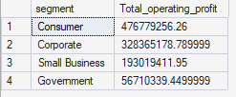
Question : Are shipping costs affecting profitability?
Products gotten from High shipping cost are eating into the profit. High Shipping Cost orders (above 15000 naira) are actively losing money. "High Shipping Cost" band has a negative total operating profit (-$133,889.52), despite having decent revenue (547,912.68).

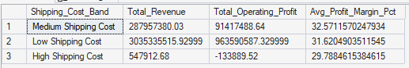

Question : Which stores should receive immediate operational attention?
More attention should be given to Ikeja and Aba branch.

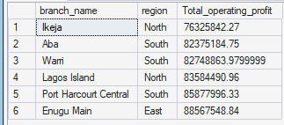
Question : what is the sale performance over the years
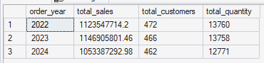

Question : Identify the top performing products categories as percentage of total sales?

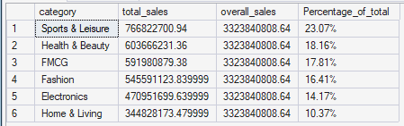

Question : Which products generate high sales but low profits?

Health& Body, Electronics and Home & Living product categories have high sales but generated low profit

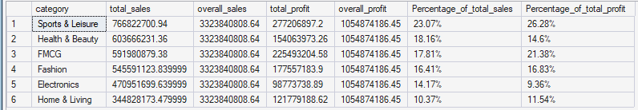

Question : Which regions contribute the most revenue but the least profit?

The south and North region generated 24.96% and 24.16% of the total revenue respectively but they generated low profit

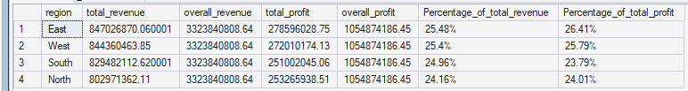

Retail Sales Analysis Dashboard
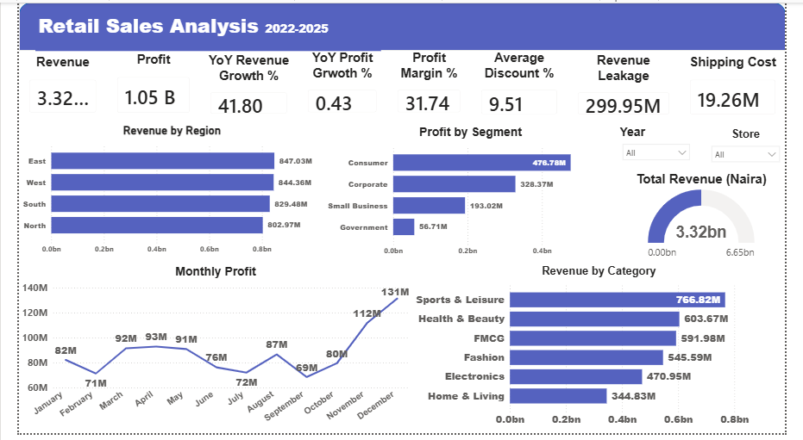

Recommendation
  - The company should stop giving discount above 15%
  - The company should consider using ‘second class’ and ‘standard class’ shipping mode since these shipping mode generated more profits
  - More attention should be giving to low performing product categories
  - Pay close attention to regions with low profits, especially the north and south region. Check if the staffs are meeting up with customers’ demand on time or if the customers there are not satisfied with the products
  - Discount for Electronics products should be reduced. I thas the highest discount rate but it till generates low profit

